# Exercises: HTML and CSS Overview

Problems for exercises and homework for the “HTML and CSS” course @ SoftUni. Submit your solutions in the SoftUni judge system at <https://judge.softuni.bg/Contests/394/HTML-and-CSS-Overview> .

## My First Page

Create a Web Page like the following.

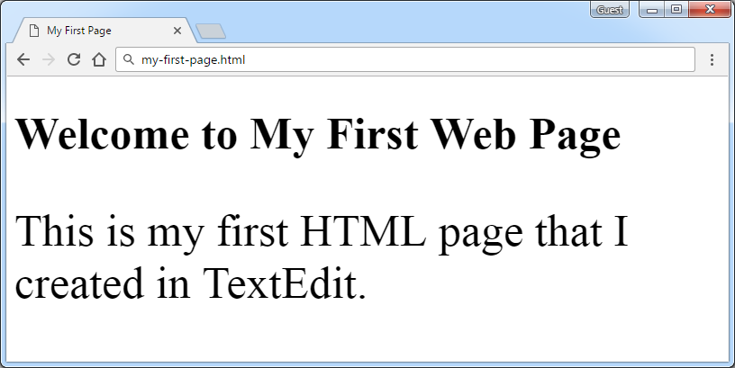

Create “**my-first-page.html**”

### Constraints

* <h1> tag for heading
* <p>tag for paragraph

## Definition Lists

Create a Web Page like the following.

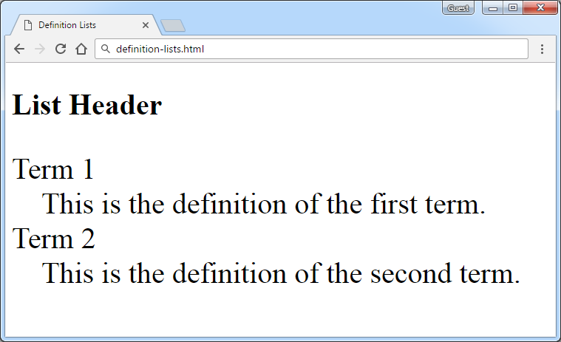

Create “**definition-lists.html**”

### Constraints

* <h2> tag for heading
* <dl>tag for definition list

## i

Create a Web Page like the following.

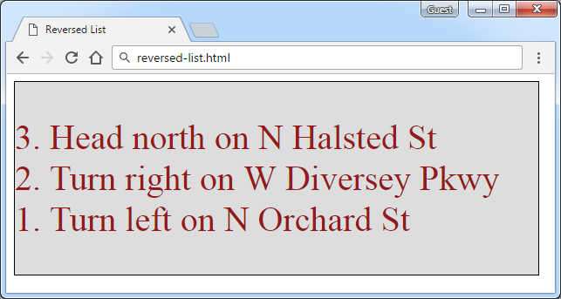

Create two files: “**reversed-list.html**”and“**reversed-list.css**”

### Constraints

* <div>with **id=wrapper** as a **container**
  + Background color: #dddddd
  + Text color: #95191a
  + Width container: 300px
  + Border: 1px solid #000000

### Hints

Use:

* <ol> with **reversed** attribute
  + <ol reversed="reversed">
* Submit **only** **reversed-list.html** + **reversed-list.css** in **ZIP** file

## The Runners Home

Create a Web Page like the following using **Runners-Home.txt**.

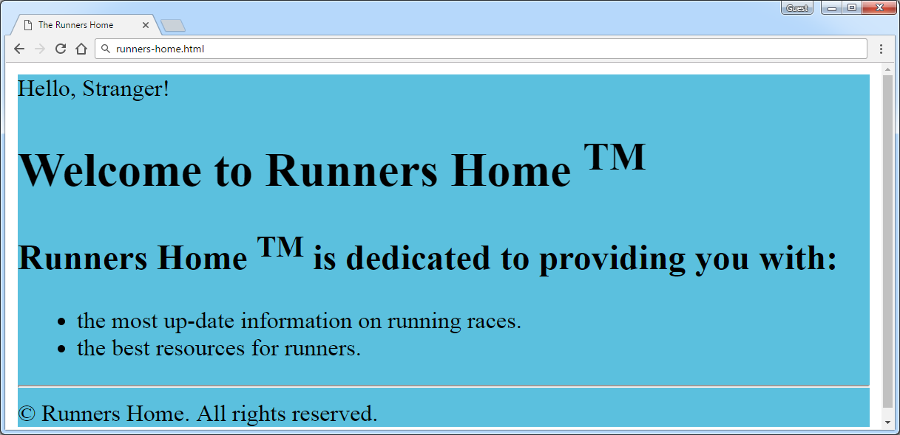

Create two files: “**runners-home.html**” and “**runners-home.css**”

### Constraints

* **<div>** with **id=wrapper** as a **container**
  + Background color: **#5bc0de**

**Hints**

Use:

* <h1> and <h2>tags for headings
* <sup>tag for **superscript text**
* <p> tag for paragraphs and <span> for Hello, Stranger!
* <ul>tag for list items
* <hr />for horizontal line
* <footer>tag for copyright part + **&copy;** for copy right symbol

## Book Story

* Create a Web Page like the following using **Book-Story.txt**.

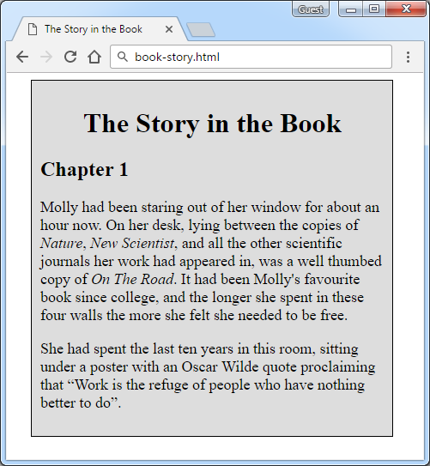

Create two files: “**book-story.html**”and“**book-story.css**”

### Constraints

* **<div>** with **id=wrapper** as a **container**
  + Width container: **400px**
  + Background color: **#dddddd**
  + Border: **1px solid #000000**
  + Margin Left**: 20px**
  + Padding**: 10px**
* **<p>** tag for paragraph + **font-size: 18px**
* **<em>** tag for italic text

### Hints

Use:

* **<h1>** tagfor heading + **center the text**
* **<q>** tag for quotation text
  + **q::before {  
     content: open-quote;  
    }**
  + **q::after {   
     content: close-quote;  
    }**

## *World Cup News

Create a Web Page like the following using **World**-**Cup-News.txt.**

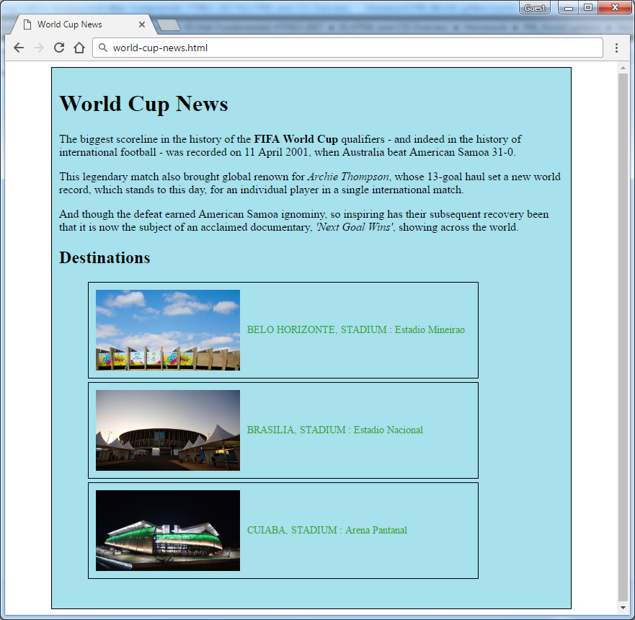

Create two files: “**world-cup-news.html**” and “**world-cup-news.css**”

### Constraints

* **<div>** with **id=** **"wrapper"** as a **container**
  + Width container: 700px
  + Height container: 730px
  + Border: 1px solid #000000
  + Center the **container**
  + Padding**:** 10px
  + Background color: #a6e1ec
* <h1>and<h2>tags for headings
* <p> tag for paragraph
* <strong>tag for **bold** text
* <em>tag for **italic** text
* <img> tag for images
  + Width: 200px
  + Margin Right: 10px
  + Vertical Align:middle
* <span class= "text">for the text next to images
  + Text color: #2EA620
* <li>tag
  + Width: 520px
  + Padding: 10px
  + Margin Bottom: 5px
  + Font Size: 14px
  + Border: 1px solid #000000